**University of Michigan – Dearborn**

**Department of Computer and Information Science**

**CIS 150L – Fall 2014**

Lab 11

Srinivas Simhan

11/30/14

**Table of Content**

1. Question 1 3
   1. Screenshot 3
   2. Source Code 3
2. Question 2 6
   1. Screenshot 6
   2. Source Code 6
3. **Question 1**
   1. **Screenshot**

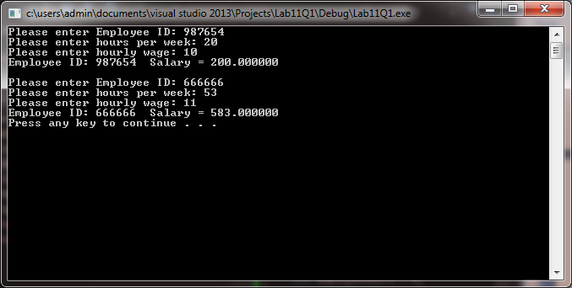

* 1. **Source Code**

**Header**

// Purpose: Define Hourly Employee Class

// Author: Srinivas Simhan

// Date Created: 11/24/2014

// Date Last Modified: 11/24/2014

#ifndef HOURLYEMPLOYEE_H // avoid multile definitions

#define HOURLYEMPLOYEE_H // not part of the class

#include <string>

class HourlyEmployee

{

public:

void setId(std::string);

void setHours(int);

void setWage(float);

std::string getWeeklySalary();

private:

std::string id; //employee id

int hours; //work hours in a week

float wage; //wage per hour

};

#endif // HOURLYEMPLOYEE_H

**Implementation**

// Purpose: Hourly Employee Class Implementation

// Author: Srinivas Simhan

// Date Created: 11/24/2014

// Date Last Modified: 11/24/2014

#include "Lab11Q1.h"

#include <iostream>

#include <string>

using namespace std;

// Set ID value

void HourlyEmployee::setId(string employeeID)

{

id = employeeID;

};

// Set Hours value

void HourlyEmployee::setHours(int employeeHours)

{

hours = employeeHours;

}

// Set Wage value

void HourlyEmployee::setWage(float employeeWage)

{

wage = employeeWage;

}

// Get weekly salary

string HourlyEmployee::getWeeklySalary()

{

return "Employee ID: " + id + " Salary = " + to_string(hours * wage); // salary = hours * wage per hour

};

**Main**

// Purpose: Using Classes to find Salary

// Author: Srinivas Simhan

// Date Created: 11/24/2014

// Date Last Modifed: 11/24/2014

#include "Lab11Q1.h"

#include <iostream>

#include <string>

using namespace std;

int main()

{

HourlyEmployee Employee_1;

HourlyEmployee Employee_2;

string employeeId = "";

int employeeHours = 0;

float employeeWage = 0;

// 1st Employee

cout << "Please enter Employee ID: ";

cin >> employeeId;

Employee_1.setId(employeeId);

cout << "Please enter hours per week: ";

cin >> employeeHours;

Employee_1.setHours(employeeHours);

cout << "Please enter hourly wage: ";

cin >> employeeWage;

Employee_1.setWage(employeeWage);

cout << Employee_1.getWeeklySalary() << endl << endl;

// 2nd Employee

cout << "Please enter Employee ID: ";

cin >> employeeId;

Employee_2.setId(employeeId);

cout << "Please enter hours per week: ";

cin >> employeeHours;

Employee_2.setHours(employeeHours);

cout << "Please enter hourly wage: ";

cin >> employeeWage;

Employee_2.setWage(employeeWage);

cout << Employee_2.getWeeklySalary() << endl;

system("pause");

return 0;

}

1. **Question 2**

**2.1 Screenshot**

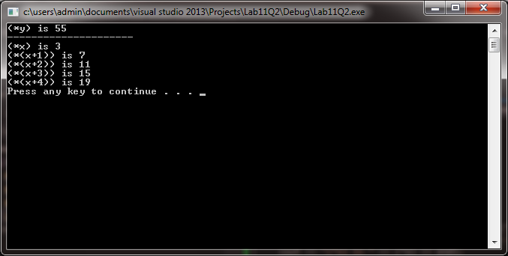

**2.2. Source Code**

// Purpose: Display Array Numbers

// Author: Srinivas Simhan

// Date Created: 11/24/14

// Date Modified: 11/24/14

#include <iostream>

#include <string>

using namespace std;

int main()

{

int *x, *y;

x = new int[5];

y = new int;

(*x) = 3;

(*(x + 1)) = 7;

(*(x + 2)) = 11;

(*(x + 3)) = 15;

(*(x + 4)) = 19;

(*(y)) = (*x) + (*(x + 1)) + (*(x + 2)) + (*(x + 3)) + (*(x + 4));

cout << "(*y) is " << (*y) << endl << "---------------------" << endl;

cout << "(*x) is " << (*x) << endl;

cout << "(*(x+1)) is " << (*(x + 1)) << endl;

cout << "(*(x+2)) is " << (*(x + 2)) << endl;

cout << "(*(x+3)) is " << (*(x + 3)) << endl;

cout << "(*(x+4)) is " << (*(x + 4)) << endl;

system("pause");

return 0;

}